EX NO: 1 INTRODUCTION

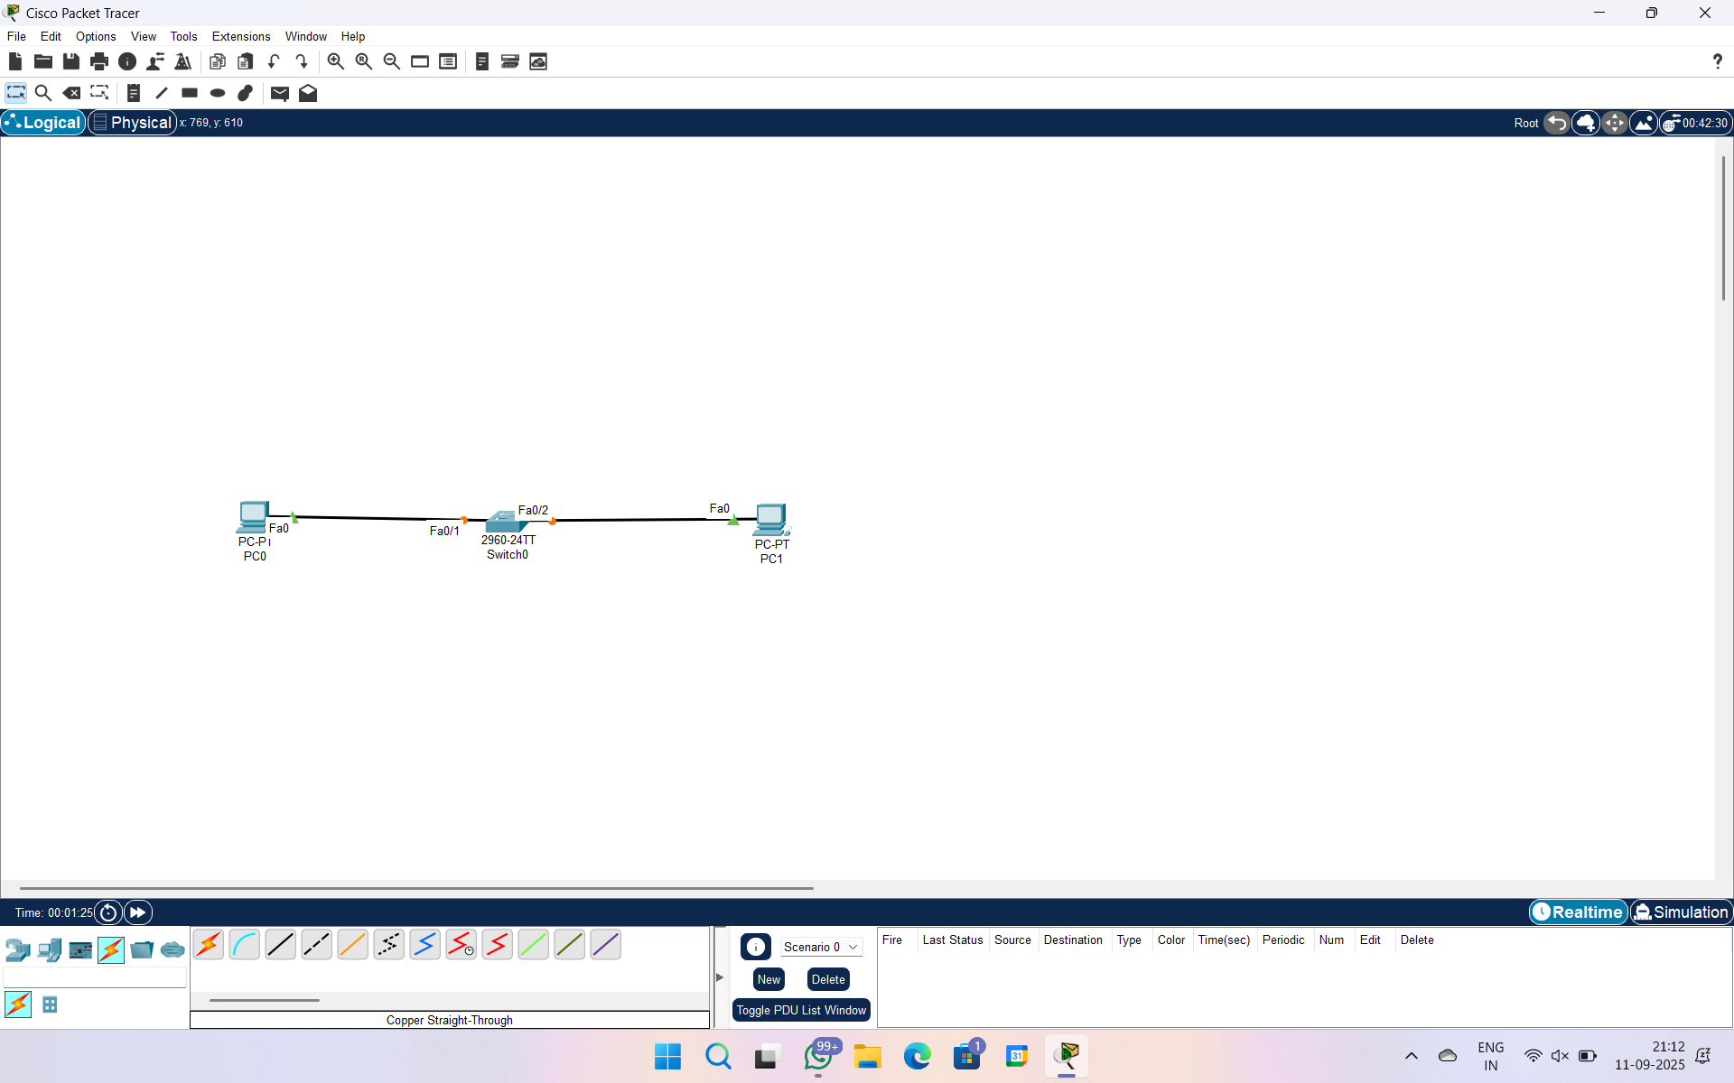

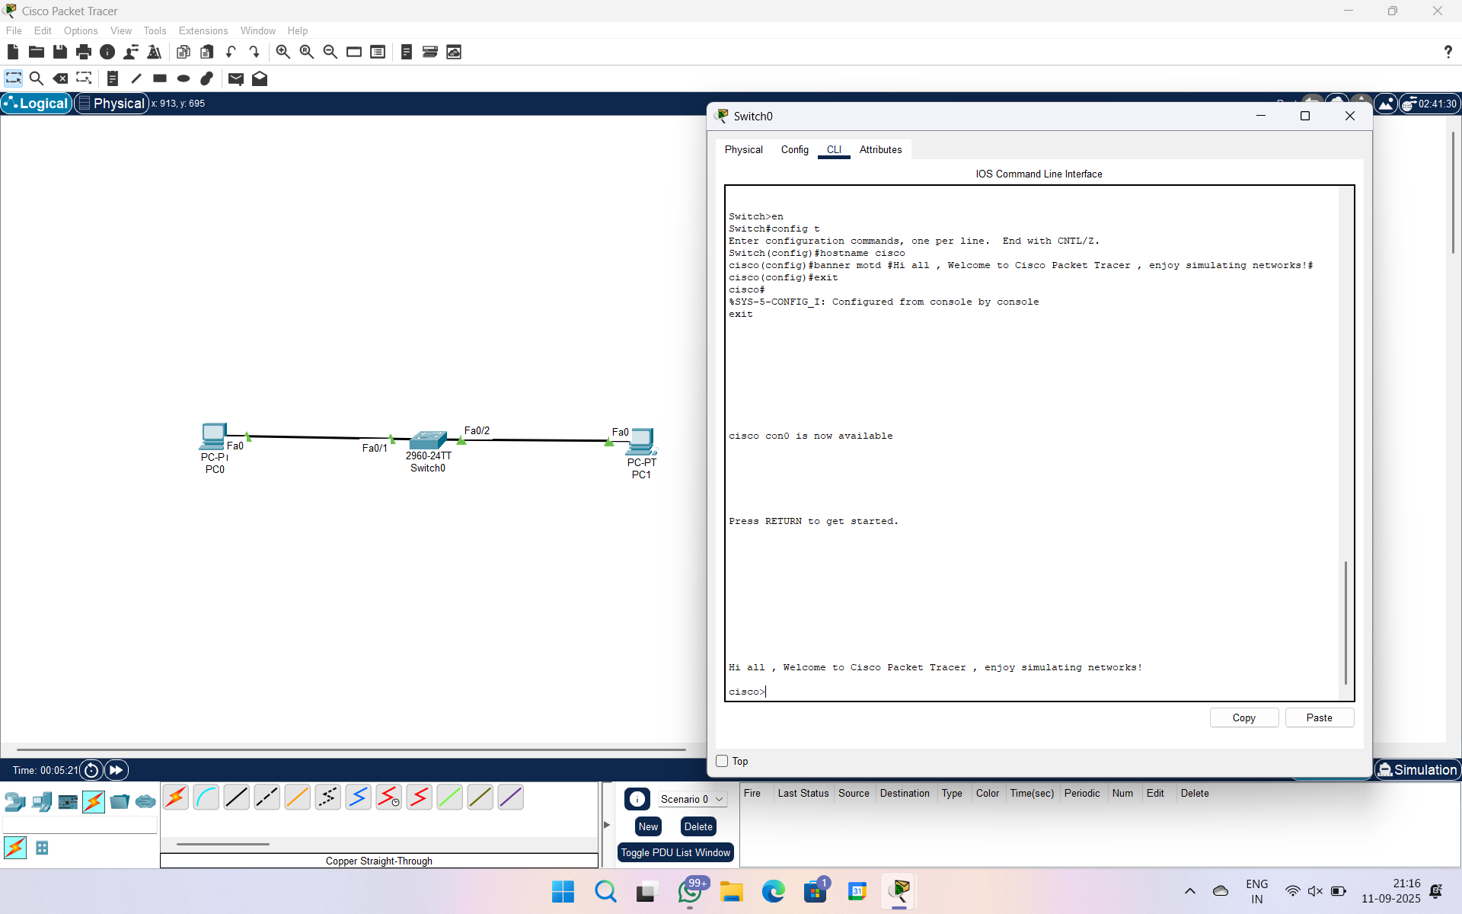

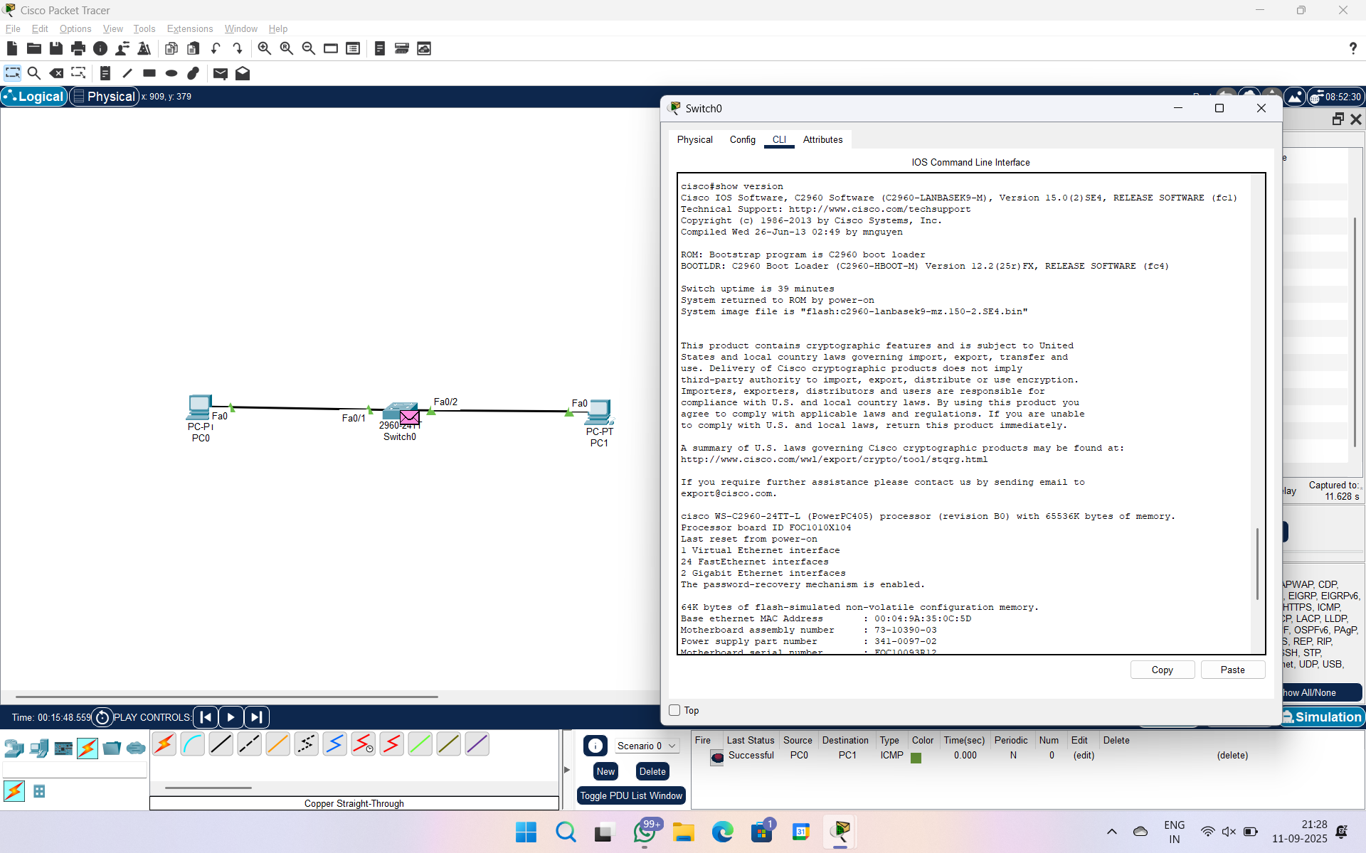

EX 2A CREATE AND DELETE VLAN – NORMAL SWITCH



